Mr. Jim Andrew, Executive Vice President, Chief Sustainability Officer

Pepsico, Inc.

700 Anderson Hill Rd

Purchase, NY 10577

Dear Mr. Andrew,

I was so excited to hear about your commitment to deforestation-free palm oil! Thank you for taking a leadership role in the journey toward sustainable palm oil. Orangutans and other wildlife are counting on your commitment to help break the link between palm oil and deforestation.

I understand there are many steps needed to ensure the palm oil you use is deforestation-free. I would like to support your journey and I look forward to hearing about your progress through:

* Your ACOP (Annual Communication of Progress) report to the RSPO.
* Publically sharing your progress through media releases and social media.
* Using the RSPO trademark on products containing 100% physical CSPO that is deforestation-free.

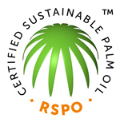

Thanks again for your deforestation-free palm oil commitment!